[](http://clipart-library.com/clipart/ziX4yd7iB.htm)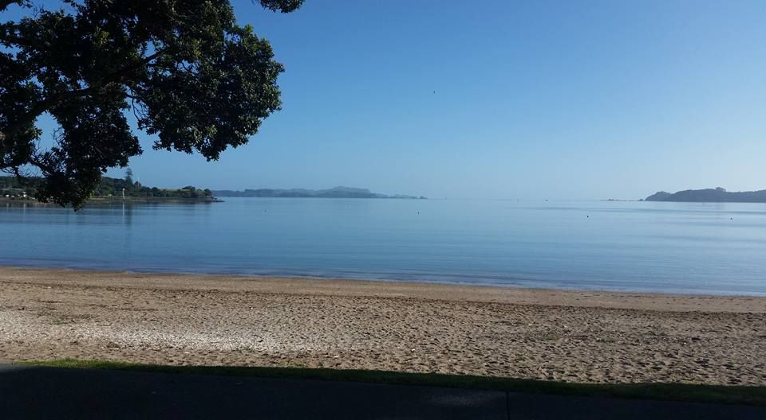[](http://clipart-library.com/clipart/ziX4yd7iB.htm)

**Naval “Get together” in Northland**

Open to all Navy and Ex-Navy personnel

Partners, Husbands, Wives all welcome

All Navy’s welcome

**Saturday 23rd June 2018**

**1230 for 1300**

**(Please note that the lunch is on Saturday)**

A Buffet Lunch and Dessert will be served

Cost for Luncheon: **$25.00** per person

**Delicious Ham on the Bone, Sweet and Sour Chicken**

**New Potatoes, Minted Peas, and 7 Salads,**

**followed by 3 or 4 desserts, Tea and Coffee**

**Bay of Islands Yacht Club, Waitangi**

**(yes, we are back at the Yacht Club)**

Raffles - $2.00 per ticket or 3 for $5.00

 A Cash Bar will be available C:\Users\Stewart.RussellRadio\AppData\Local\Microsoft\Windows\Temporary Internet Files\Content.IE5\WDG6YG4B\MC900437986[1].wmf